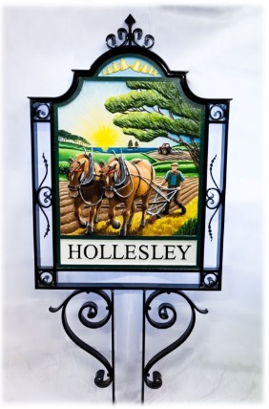
HOLLESLEY PARISH COUNCIL

Mrs. Judi Hallett, Clerk to the Council
Manor Farm, Hollesley
Woodbridge, Suffolk, IP12 3NB

Tel: 01394 411405 / 07739 411927 hollesleyparishclerk@gmail.com

GRANT APPLICATION FORM

Applications should be returned to the Parish Council by 31st October (email address above). Please complete each box (giving additional information if you feel it will be useful) and please ensure you enclose a copy of your most recent accounts with your application.

Good luck!

Hollesley Parish Council
Contact Details

ORGANISATION NAME
CONTACT NAME AND ADDRESS
CONTACT TEL NO
CONTACT EMAIL
SIGNED ON BEHALF OF ORGANISATION
(not necessary if sending electronically)
DATE

Your Project

PLEASE DESCRIBE THE PROJECT OR ACTIVITY FOR WHICH YOU ARE SEEKING A GRANT.

It many be useful to know the intention of you project, where the project will be situated, which Hollesley residents will benefit from the project, if it is a ‘one off’ project or an ongoing activity, etc..

Please give as much information as you can

Funding Amount

PLEASE STATE THE TOTAL COST OF YOUR PROJECT/ACTIVITY | £
PLEASE STATE THE AMOUNT OF GRANT YOU ARE APPLYING FOR FROM THE PARISH COUNCIL | £
IF APPLICABLE PLEASE INDICATE HOW THE REMAINDER OF THE PROJECT WILL BE FUNDED

If the amount of grant you are asking for is less than the total cost of the project we need to know how the remaining funding will be raised and where you have sought alternative funding

IF YOU ARE SUCCESSFUL IN RECEIVING A GRANT, PLEASE PROVIDE YOUR BANK ACCOUNT DETAILS? | Bank:  Account Name:  Account Number:  Sort Code:

ALL APPLICATIONS WILL BE ACKNOWLEDGED AND DETAILS OF ANY GRANT AWARDED WILL BE NOTIFIED TO YOU DURING NOVEMBER

BANK TRANSFERS FOR ALL SUCCESSFUL APPLICATIONS WILL BE PAID NEXT APRIL

DON’T FORGET TO SEND A COPY OF YOUR ACCOUNTS WITH YOUR APPLICATION. GOOD LUCK!

