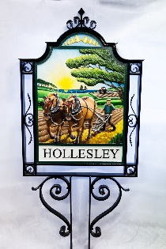
HOLLESLEY PARISH COUNCIL
Mrs Judi Hallett, Clerk to the Council
Manor Farm, Hollesley, Woodbridge Suffolk IP12 3NB

Tel: 01394 411405 / 07739 411927 hollesleyparishclerk@gmail.com

Oak Hill Social Club Path – Maps

Map 1
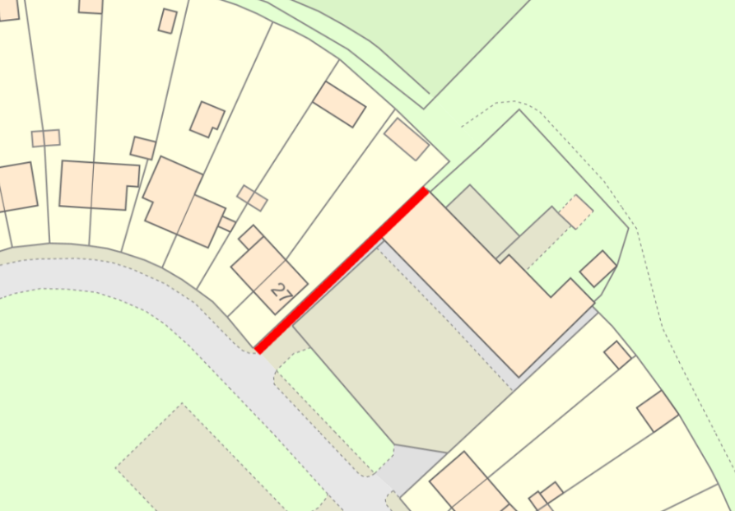

Map 2
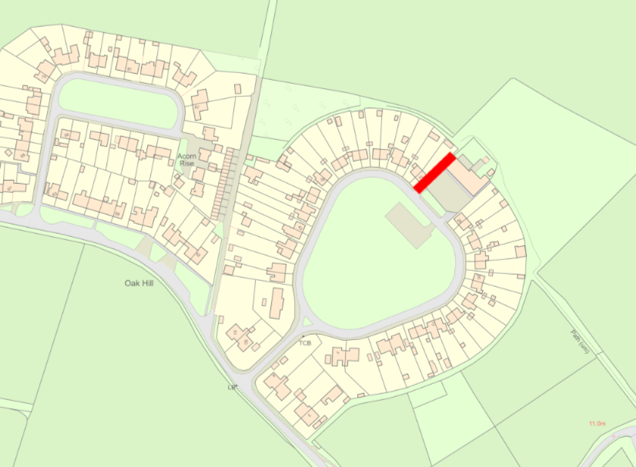

Map Co-ordinates
- W3W = ///shepherds.hiding.nobody to ///sparks.relished.linked
- Grid Ref = 52.057796, 1.453028 to 52.058047, 1.453501

